 | INTERNATIONAL TELECOMMUNICATION UNION
 | RADIOCOMMUNICATION  STUDY GROUPS | Document 8B/111-E
 | RADIOCOMMUNICATION  STUDY GROUPS | 18 February 2005
 | RADIOCOMMUNICATION  STUDY GROUPS | English only
Source: Document 1-9/TEMP/32 JRG-28
Task Group 1/9
liaison statement to working party 8b and
for information to JRG 1a-1c-8b
Compatibility analysis between the Earth exploration-satellite (passive) service systems
[operating] in the 1 400-1 427 MHz band and radiolocation service systems operating in the 1 350-1 400 MHz band

At its meeting in February 2005, Task Group 1/9 received a contribution on a method to revise Annex 3 of Recommendation ITU-R SM.1633, which discusses the compatibility between the EESS (passive) systems operating in the 1 400-1 427 MHz band and radiolocation systems operating in the 1 350-1 400 MHz band. Annex 3 of Recommendation ITU-R SM.1633 made use of Recommendation ITU-R SM.1541, thereby only utilizing an envelope (peak emission) mask that when integrated over the EESS (passive) bandwidth could result in a large overestimation of the unwanted emission power falling into the passive band.
The contribution proposes the use of spectral representations based on Fourier analysis in order to give a more accurate estimation of the unwanted emission power falling into the passive band. Comparisons between the two methods (based on Recommendation ITU-R SM.1541 and one based on Fourier analysis) are given.
The developed method compares well to results given in Document JRG-1A-1C-8B/12 (“Comparison of methods used to predict the bandwidth of radar emissions”) by using the same parameters. A pulse rise time of 50 ns has been used in most analyses (as contained in Annex 3 of Recommendation ITU-R SM.1633 – resulting from a liaison statement from WP 8B directed to TG 1/7). Linear FM chirp is being used to characterize the signal modulation. Radar characteristics have been extracted from Recommendation ITU-R M.1463. The study resulted in a more favourable compatibility situation for the method relying on Fourier analysis (“spectrum method”), but still discrepancies existed between the power received by the EESS (passive) sensor and the interference threshold whilst assuming a radar antenna gain of 0 dBi.
Also, the amount of frequency separation between the passive band and the radar channel’s centre frequency was investigated for two radar systems with respect to a specific EESS (passive) sensor to show the potential for this method for unwanted emission power calculation for radar systems.
Although the resulting radar spectra are for theoretical pulses, this method does resemble the real radar emission characteristics more than a mask would do. No allowance has been made for distortions that may occur in a practical situation, but also no filtering characteristics (or inherit spectral attenuation of the radar hardware such as use of wave guides) of the radars have been investigated that would result in a more favourable situation.
Where this contribution discusses the static analyses, it is envisaged that a future revision of this document for the next meeting of Task Group 1/9 would also include statistical/dynamic analyses. This preliminary study only takes into account the interference threshold from Recommendation ITU-R SA.1029, but also the availability criterion (defined in Recommendation ITU-R SA.1029 as the percentage of area the permissible interference level may be exceeded) needs to be taken into account. By also taking this availability criterion into account (for the statistical/dynamical analyses), depending on the density of radars and probability of channel occupation near the passive band, within the measurement area, the apparent incompatibility may be alleviated to a great extent.
In order to refine these calculations, Task Group 1/9 would like to request information on a realistic density model for these radar systems (for Systems 1-4) as well as on any additional information to be used for the refinement such as probability of channel occupation near the passive band and filtering characteristics.

Attachment: Document 1-9/TEMP/39

Contact: Björn ROMMEN (ESA)
E-mail: Bjorn.Rommen@esa.int
Attachment
Source: Document 1-9/TEMP/39
working document on the methodology to revise ANNEX 3 to Recommendation itu-r SM.1633:
Compatibility analysis between the Earth exploration-satellite (passive) service systems operating in the 1 400-1 427 MHz band and radiolocation service systems operating in the 1 350-1 400 MHz band

1 Introduction
Annex 3 of Recommendation ITU-R SM.1633 discusses the compatibility between the EESS (passive) systems operating in the 1 400–1 427 MHz band and radiolocation systems operating in the 1 350–1 400 MHz band. Available information at that time only permitted the use of Recommendation ITU-R SM.1541, thereby only utilising an envelope mask that when integrated over the EESS (passive) bandwidth could result in a large overestimation of the unwanted emission power falling into the passive band.
This contribution proposes the use of spectral representations based on Fourier analysis in order to give a more accurate estimation of the unwanted emission power falling into the passive band. Comparisons between the 2 methods (based on Rec. ITU-R SM.1541 and one based on Fourier analysis) will be given.

2 Simulated radar spectra
In order to arrive to accurate spectral representations of modulated and unmodulated radar signals, first the shape of the pulse needs to be taken into account. Here, trapezoidal pulses will be used where pulse rise- and fall-times are similar thus resulting in a symmetrical pulse shape for unmodulated pulses. The developed method compares well to results given in
Document JRG-1A-1C-8B/12 (“Comparison of methods used to predict the bandwidth of radar emissions”) by using the same parameters. A pulse rise time of 50 ns has been used in most analyses (as contained in Annex 3 of Rec. ITU-R SM.1633 - resulting from a liaison statement from WP 8B directed to TG 1/7). Linear FM chirp is being used to characterize the signal modulation.
Radar characteristics have been extracted from Recommendation ITU-R M.1463 and are here repeated in Table 1.
TABLE 1
1 215-1 400 MHz radiodetermination system characteristics
Parameter | System 1 | System 2 | System 3 | System 4
Peak power into  antenna (dBm) | 97 | 80 | 76.5 | 80
Pulse duration (μs) | 2 | 88.8;  58.8  (Note 1) | 0.4; 102.4;  409.6  (Note 2) | 39 single frequency  26 and 13 dual frequency (Note 3)
Pulse repetition rate (pps) | 310-380  staggered | 291.5 or 312.5  average | 200-272 long range  400-554 short range | 774 average
Chirp Bandwidth for frequency modulated (chirped) pulses | Not applicable | 770 kHz for both pulse widths | 2.5 MHz for  102.4 μs  625 kHz pour 409.6 μs | Not applicable
Phase-coded sub-pulse  width (μs) | Not applicable |  |  | 1
Compression ratio | Not applicable | 68.3:1 and 45.2:1 | 256:1 for both pulses
RF emission bandwidth (3 dB) (MHz) | 0.5 | 1.09 | 2.2;  2.3;  0.58; | 1
Output device | Klystron | Transistor |  | Cross field amplifier
Antenna type | Horn-fed reflector | Stack beam reflector | Rotating phased array | Parabolic cylinder
Antenna polarization | Horizontal, vertical,  LHCP, RHCP | Vertical, circular | Horizontal | Vertical
Antenna maximum  gain (dBi) | 34.5, transmit  33.5, receive | 32.4-34.2, transmit  31.7-38.9, receive | 38.9, transmit  38.2, receive | 32.5
Antenna elevation beamwidth (degrees) | 3.6 shaped to 44 | 3.63-5.61, transmit  2.02-8.79, receive | 1.3 | 4.5 shaped to 40
Antenna azimuthal beamwidth (degrees) | 1.2 | 1.4 | 3.2 | 3.0
Antenna horizontal scan characteristics (rpm) | 360° mechanical at 5 rpm |  | 360° mechanical at  6 rpm for long range and 12 rpm for short range | 360° mechanical at  6, 12 or 15 rpm
Antenna vertical scan characteristics | Not applicable | –7° to +30°  in 12.8 or 13.7 ms | –1° to +19°  in 73,5 ms | Not applicable
Receiver IF bandwidth | 780 kHz | 0.69 MHz | 4.4 to 6.4 MHz | 1.2 MHz
Receiver noise figure (dB) | 2 |  | 4.7 | 3.5
Platform type | Fixed |  | Transportable
Percentage of time  system operates (%) | 100
NOTE 1 – The radar has 44 RF channel pairs with one of 44 RF channel pairs selected in normal mode. The transmitted waveform consists of a 88.8 μs pulse at frequency f1 followed by a 58.8 μs pulse at frequency f2. Separation of f1 and f2 is 82.854 MHz.
NOTE 2 – The radar has 20 RF channels in 8.96 MHz increments. The transmitted waveform group consists of one 0.4 μs P0 pulse (optional) which is followed by one 102.4 μs linear frequency modulated pulse (if 0.4 μs P0 is not transmitted) of 2.5 MHz chirp which may be followed by one to four long range 409.6 μs linear frequency modulated pulses each chirped 625 kHz and transmitted on different carriers separated by 3.75 MHz. Normal mode of operation employs frequency agility whereby the individual frequencies of each waveform group are selected in a pseudo-random manner from one of the possible 20 RF channels within the 1 215-1 400 MHz band.
NOTE 3 – The radar has the capability of operating single frequency or dual frequency. Dual RF channels are separated by 60 MHz. The single channel mode uses the 39 μs pulse width. In the dual channel mode, the 26 μs pulse is transmitted at frequency f, followed by the 13 μs pulse transmitted at f + 60 MHz.

The radar spectra can then be compared to the OoB mask for primary radars as contained in Figure 25 of Annex 8 to Recommendation ITU-R SM.1541 (page 48). Since the mask is expressed in a frequency separation as a percentage of the –40 dB bandwidth (B₋₄₀), B₋₄₀ is obviously dependent on the radar parameters and needs to be calculated according to formulas in Annex 8 (Rec. ITU-R SM.1541).
Calculations have been performed for System 1 and System 2, where one is a representative system with no pulse modulation and the other is a representative system with pulse modulation (i.e. linear FM chirp).
For System 1 a reference is shown in Figure 1, where between 50 – 500 % of B₋₄₀ (the other 50 % of B₋₄₀ is located on the negative frequency axis which is not shown here) the mask and the maximum values of the radar spectrum agree when no pulse rise- and fall-times are assumed (i.e. perfectly rectangular pulse).
FIGURE 1
Reference figure for a perfectly rectangular radar pulse with 2 μs pulse length 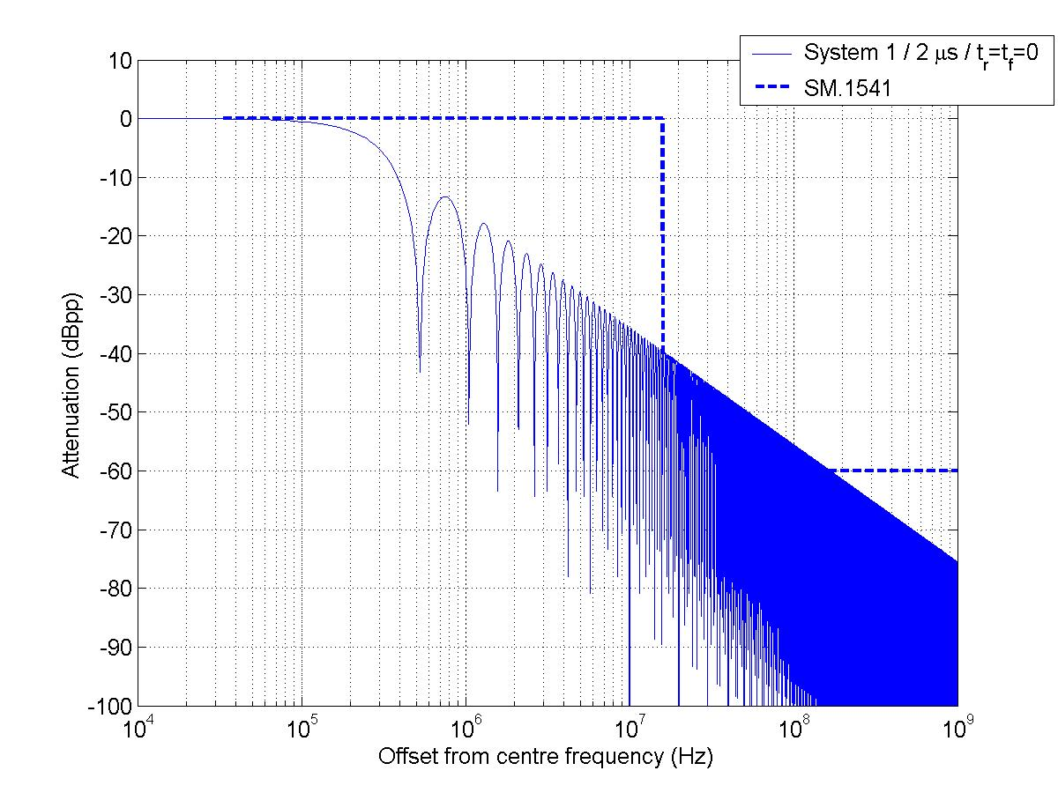
Figure 1 clearly shows the roll-off of 20 dB per decade and maximum values of the radar spectrum match the mask between 50 to 500 % of B₋₄₀ .
Since a perfectly rectangular pulse does not exist in practice, pulse rise- and fall-times for radar systems need to be used in order to characterize the radar spectrum. The shorter the pulse rise- and fall-times, the wider spectra will occur in the radar spectrum and thus resulting in a slower roll-off of the radar spectrum.
FIGURE 2
System 1 (2 μs pulse length) including pulse rise- and fall-time of 50 ns
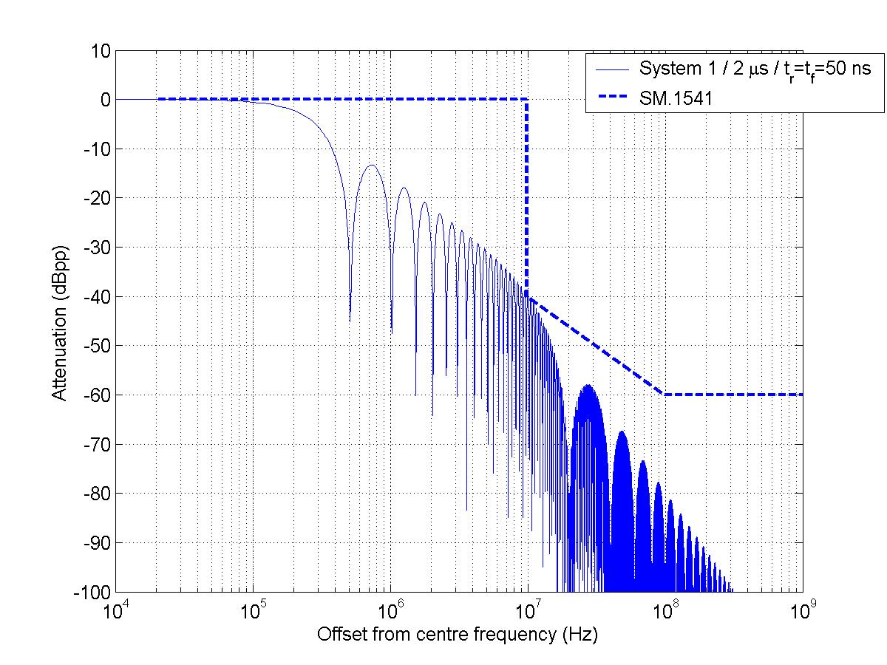
Figures 2 and 3 show this for System 1 with pulse rise times of 50 ns and 100 ns, respectively. The masks at 50 % of the –40 dB bandwidth (B₋₄₀) agree well with the radar spectra, but both spectra roll off with 40 dB per decade from 50 % of B₋₄₀. At 500 % of B₋₄₀, the difference between the mask and the simulated spectra is around 20 dB.
Table 2 reflects the necessary and –40 dB bandwidths for System 1 (according to Rec. ITU-R SM.1541) for the investigated pulse rise times.
TABLE 2
Necessary and –40 dB bandwidths for System 1 for different pulse rise times
SYSTEM 1 | t_{r}=t_{f}=0 (Fig. 1) | t_{r}=t_{f} =50ns (Fig. 2) | t_{r}=t_{f} =100ns (Fig. 3)
B_{n} | 3.18 MHz | 3.18 MHz | 3.18 MHz
B₋₄₀ | 32.0 MHz | 19.6 MHz | 13.9 MHz

FIGURE 3
System 1 (2 μs pulse length) including pulse rise- and fall-time of 100 ns
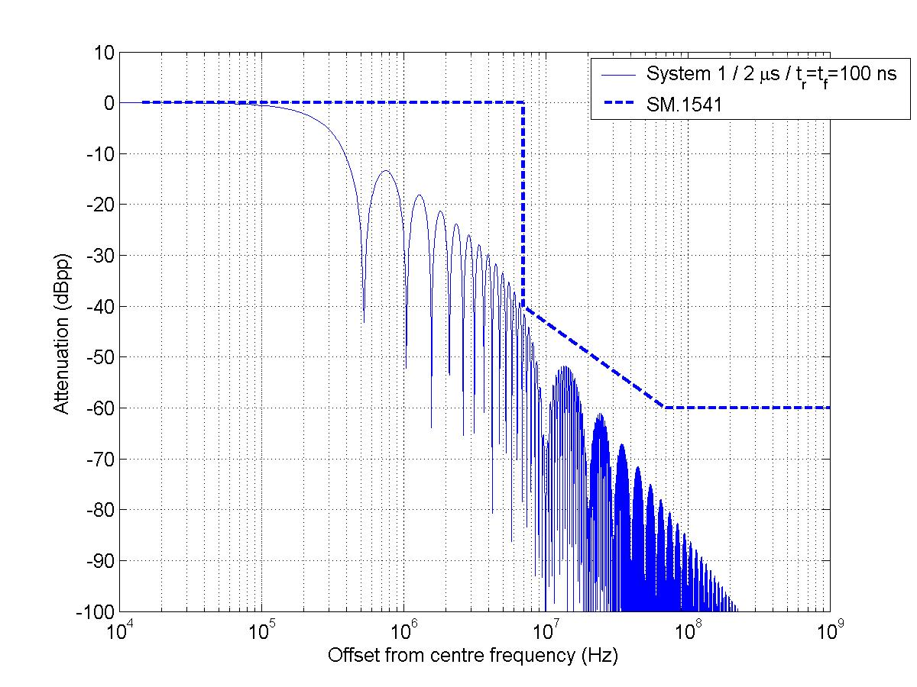
Also for System 2 emission spectra have been generated. These are shown in Figures 4 and 5. As System 2 is a linear frequency modulated (chirped) radar system, the simulation takes this into account. Figure 4 shows the radar spectrum for a 58.8 μs pulse length, whereas Figure 5 shows the radar spectrum for a 88.8 μs pulse length. The chirp bandwidth is 770 kHz for both pulse lengths.
For both figures the mask largely overestimates the simulated spectra and at 50 % of the –40 dB bandwidth, maximum values of the radar spectra do not correspond to the same point as the mask (as was the case with the unmodulated radar signal spectra).
Table 3 reflects the necessary and –40 dB bandwidths for System 2 (according to Rec. ITU-R SM.1541) for the investigated pulse lengths.
TABLE 3
Necessary and –40 dB bandwidths for System 2
SYSTEM 2 | B_{n} | B₋₄₀
58.8 μs / 50 ns | 2.58 MHz | 9.36 MHz
88.8 μs / 50 ns | 2.39 MHz | 8.68 MHz

FIGURE 4
System 2 (58.8 μs pulse length) / pulse rise- and fall-time of 50 ns
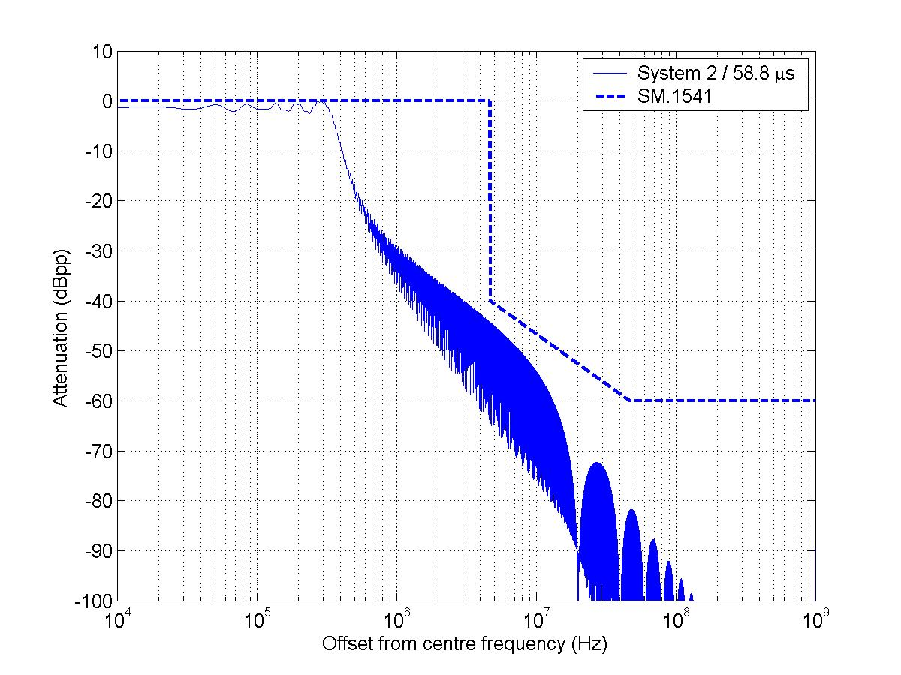
FIGURE 5
System 2 (88.8 μs pulse length) / pulse rise- and fall-time of 50 ns
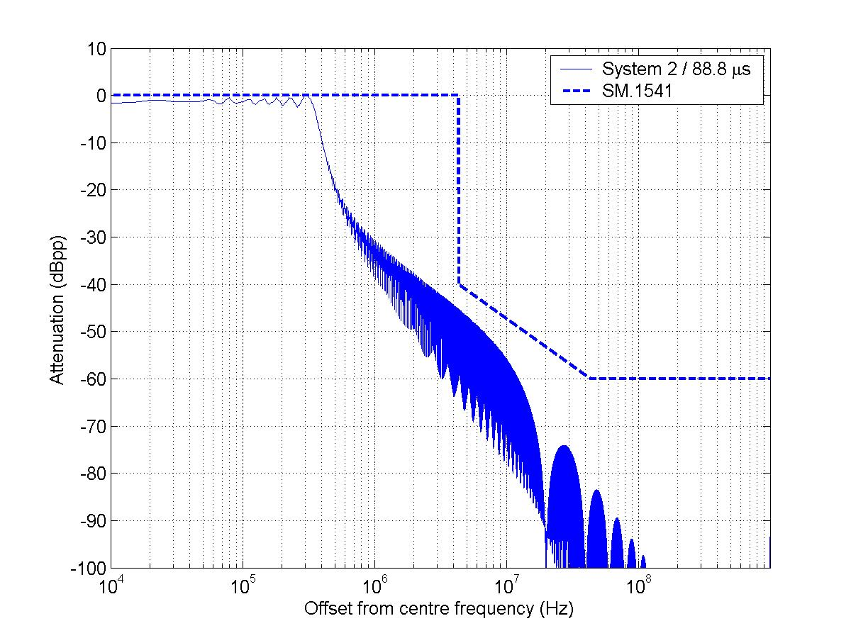

3 Radar unwanted emission power into passive band
From the developed masks and spectra, the radar signal attenuation is known compared to the in-band situation. Since also the peak power into the antenna is given, estimations can be made on the amount of power falling into the passive band 1400 – 1427 MHz in order to arrive to the unwanted emission power at the radar antenna port. This should form the basis for the compatibility analysis.
As in Annex 3 of Rec. ITU-R SM.1633, the initial assumption that the start of the passive band (i.e. 1 400 MHz) is located at the offset frequency corresponding to the mask’s –40 dB attenuation point, which is 50 percent of B₋₄₀, is used here as well.
For the 2 different methods, i.e. the envelope mask from Rec. ITU-R SM.1541 and the ‘spectrum’ method, averaged attenuation levels relative to the maximum value of the peak power and the total unwanted emission power in the passive band 1 400–1 427 MHz from radar system 1 and 2 have been calculated. Results are shown in Table 4 and Table 5 for System 1 and System 2, respectively. System 1 has been differentiated for different pulse rise times (0, 50 and 100 ns), whereas System 2 has been simulated for the 2 different pulse lengths (58.8 and 88.8 μs).
TABLE 4
Unwanted emission power levels into passive band for the 2 different methods
SYSTEM 1 | Attenuation  SM.1541 | Power in passive band  SM.1541 | Attenuation  Spectrum | Power in passive band  Spectrum
t_{r}=t_{f}=0 | -44.4 dBpp | 39.9 dBW | -46.9 dBpp | 37.1 dBW
t_{r}=t_{f}=50 ns | -45.8 dBpp | 38.5 dBW | -52.8 dBpp | 31.3 dBW
t_{r}=t_{f}=100 ns | -47.0 dBpp | 37.3 dBW | -57.0 dBpp | 27.1 dBW

TABLE 5
Unwanted emission power levels into passive band for the 2 different methods
SYSTEM 2 | Attenuation  SM.1541 | Power in passive band  SM.1541 | Attenuation  Spectrum | Power in passive band  Spectrum
58.8 μs | -48.4 dBpp | 15.6 dBW (36.0 W) | -58.0 dBpp | 8.8 dBW (7.6 W)
88.8 μs | -48.7 dBpp | 15.3 dBW (33.7 W) | -59.1 dBpp | 7.7 dBW (5.9 W)

For System 1, the 2 methods differ in a range from around 3 dB (t_{r}=0) to over 10 dB (t_{r}=100 ns) for a situation where the passive band starts at 50 percent of B₋₄₀. For System 2, differences in power level are around 7 dB. For a larger offset from the radar centre frequency the differences in power levels will drastically grow (as has been shown in the figures). This will be further detailed in the next section.

4 Compatibility analyses
In this section, the calculated power levels in the passive band will be used in compatibility analyses in order to demonstrate the method. Here, only the static case will be investigated. The characteristics for the EESS (passive) for the band 1 400–1 427 MHz are detailed in Annex 3 of Recommendation ITU-R SM.1633 on page 31. The analyses will involve two different instruments, i.e. SMOS and HYDROS, where the main differences (related to this study) are the antenna gain (9 dBi for SMOS; 35 dBi for HYDROS), altitude and pointing direction, where the latter 2 combined result in a different free space loss. Sample calculations will be made with a radar antenna gain of 0 dBi.
TABLE 6
Compatibility analysis with radar (radar antenna gain=0 dBi)
 | System 1 / 50 ns |  | System 2 / 58.8 μs |  | System 2 / 88.8 μs
Power in passive band (dBW) | 31.3 |  | 8.8 |  | 7.7
Duty cycle allowance (dB) | -31.2 |  | -17.7 |  | -15.9
Free space loss SMOS/HYDROS (dB) | 152.9 | 154.4 | 152.9 | 154.4 | 152.9 | 154.4
Sensor ant gain SMOS/HYDROS (dBi) | 9 | 35 | 9 | 35 | 9 | 35
Interference threshold (dBW) | -174 |  | -174 |  | -174
Discrepancy (dB) | 30.2 | 54.7 | 21.2 | 45.7 | 21.9 | 46.4

As can be seen in Table 6, power levels in the passive band reach levels that are largely above the interference criterion of –174 dBW with discrepancy values ranging from 21.2 to 54.7 dB. Obviously, the main reason for this apparent incompatibility is the very high peak power of the radar systems as well as the very close proximity of the radar channel’s centre frequency to the passive band. Using the same peak power levels, the separation between the highest radar channel’s centre frequency and the passive band can be investigated using the developed method.
FIGURE 6
Radar offset frequency w.r.t. unwanted emission power falling into passive band for System 1
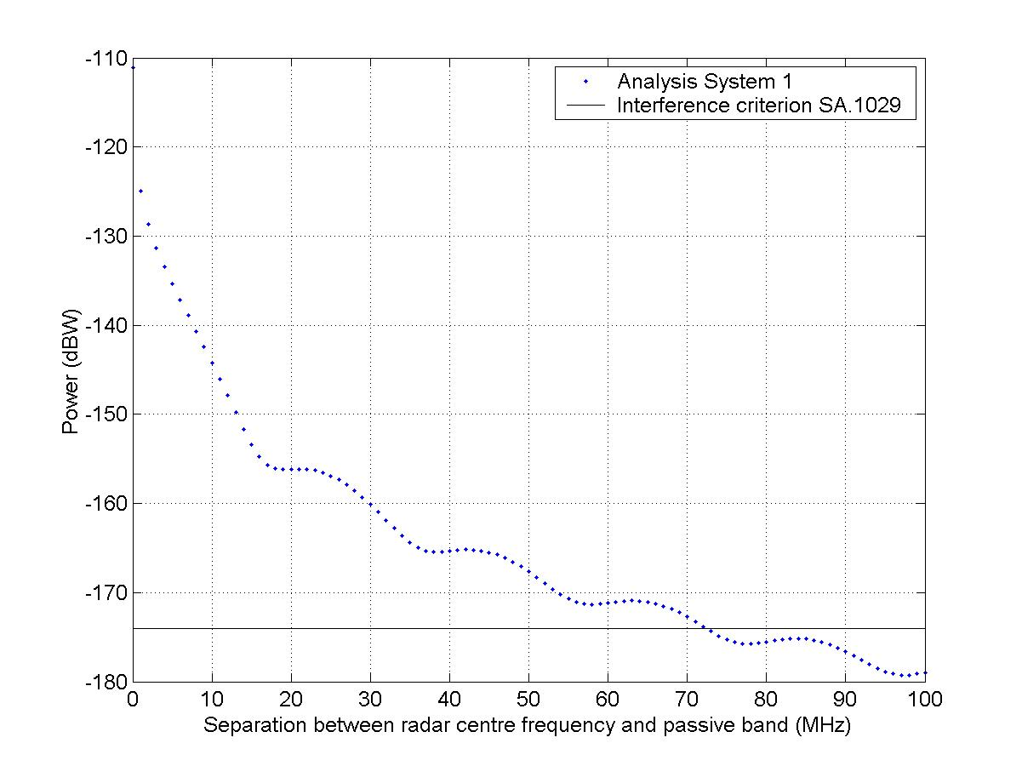
FIGURE 7
Radar offset frequency w.r.t. unwanted emission power falling into passive band for System 2
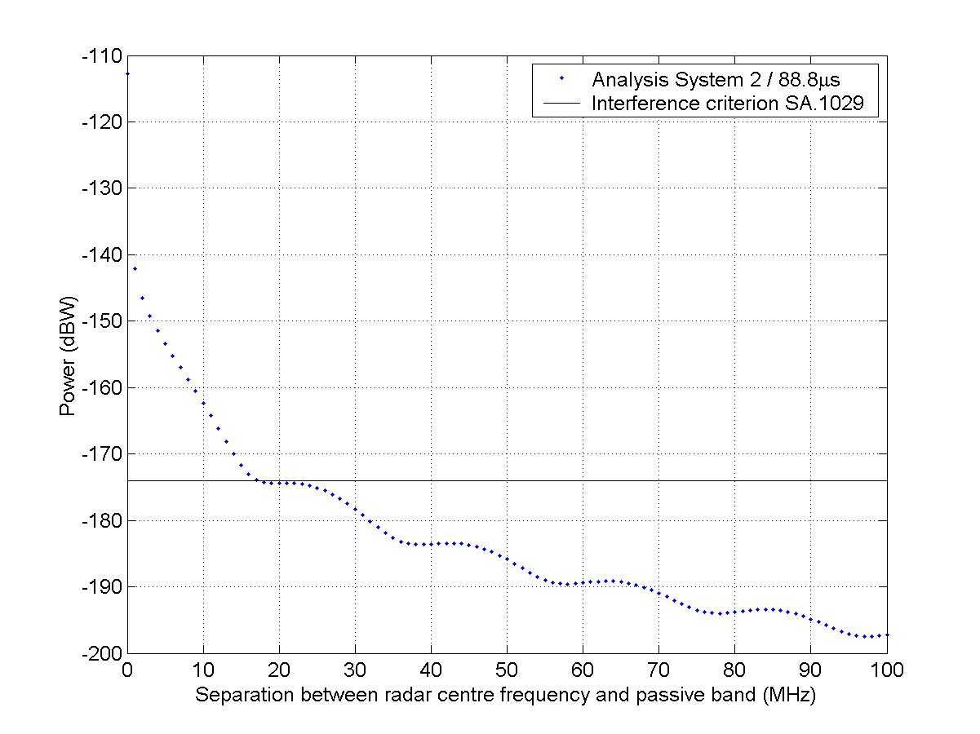
For System 1 the analysis (see Figure 6) resulted in a compatible situation when a 72.5 MHz separation would exist between the radar centre frequency and the (start of the) passive band. For System 2 (the analysis for a 58.8 μs pulse length resulted in a nearly similar result), as shown in Figure 7, the analysis resulted in a compatible situation when a 17.5 MHz separation would exist between the radar centre frequency and the (start of the) passive band. Both results only reflect the compatibility between a radar system and SMOS (for HYDROS the ‘analysis’ curves are displaced by +24.5 dB).

5 Conclusion and recommendation
In this document the use of spectral representations based on Fourier analysis is proposed in order to give a more accurate estimation of the unwanted emission power falling into the passive band. Comparisons between the 2 methods (based on SM.1541 and one based on Fourier analysis) were given and compatibility analyses were done for the situation when the –40 dB bandwidth of the radar system is equal to the start of the passive band. Clearly, this resulted in a more favourable compatibility situation for the method relying on Fourier analysis (‘spectrum method’), but still discrepancies between the power received by the EESS (passive) sensor and the interference threshold were in all cases above 20 dB. In all cases a radar antenna gain of 0 dBi has been assumed.
Also, the amount of frequency separation between the passive band and the radar channel’s centre frequency was investigated for the two radar systems with respect to SMOS to show the potential for this method for unwanted emission power calculation for radar systems.
Although the shown radar spectra are for theoretical pulses, this method does resemble the real radar emission characteristics more than a mask would do. No allowance has been made for distortions that may occur in a practical situation, but also no filtering characteristics of the radars have been investigated that would result in a more favourable situation. The main result from the static analyses is that mainly due to the very high peak powers (of the radar systems under investigation), without any large frequency offset from the passive band or filtering, the incompatibility remains.
Where this contribution discusses the static analyses, it is envisaged that a future revision of this document for the next meeting of Task Group 1/9 would also include statistical/dynamical analyses. This preliminary study only takes into account the interference threshold from Recommendation ITU-R SA.1029 and also the availability criterion (defined in SA.1029 as the percentage of area the permissible interference level may be exceeded) needs to be taken into account. By also taking this availability criterion into account (for the statistical/dynamical analyses), depending on the density of radars and probability of channel occupation near the passive band, within the measurement area, the apparent incompatibility may be alleviated to a great extent.

____________

